[](https://www.google.com.br/url?sa=i&rct=j&q=&esrc=s&source=images&cd=&cad=rja&uact=8&ved=2ahUKEwiWy7-Tk-DdAhVHQ5AKHSU9BlUQjRx6BAgBEAU&url=http://www.fisksl.com.br/&psig=AOvVaw3qW018lwY6fFPFBdaylLor&ust=1538307628832562)

Pedro Fernando Christofoletti dos Santos

**THE POWER OF BODY LANGUAGE**

**FISK FINAL**

Teacher: Danielli Hladki

**Rio Claro - SP**

**2018**

**Pedro Fernando Christofoletti dos Santos**

**THE POWER OF BODY LANGUAGE**

Body language is the unspoken element of communication that we use to reveal our true feelings and emotions. Our gestures, facial expressions and posture, for instance. When we are able to read these signs, it can be used to our advantage at anyplace at any time.

**Rio Claro – SP**

**2018**

**ACKNOWLEDGMENT**

Firstly, I would like to express my special thanks of gratitude to my teacher Danielli Hladki who gave me the required knowledge to do this project and by doing so, made me a better person with greater understanding of the world. I also thank all Fisk employees who are constantly working to make this school even better than already is.

Secondly, I would also like to thank my parents who gave me the opportunity to study at Fisk and made all this possible.

**SUMARY**

**Introduction** **5**

**1. What is body language?**  **5**

**2. How to read people’s body language?**  **6**

**3. Man vs Female body language** **6**

3.1. Men and Women body language Cues 7

3.2 Men, Women and lying 8

3.3 Men like availability over all else  9

3.3.1 Male Attraction 9

3.4 Female Flirting Behavior 9

**4. Colors** 10

**5. Body language signs of attraction backed by science**  **11**

5.1. The Basics of the Body Language of Attraction 11

5.2 Step One: First Impressions 11

5.2.1 Step Two: Attract Them While You Can 11

5.2.1 Steep Tree: Find the Sign 12

**6. Expressions** 12

6.1. Eyes 13

6.2. Mouth 13

6.3. Arms and legs 13

6.4. Body 14

**Closing** **15**

**Sources** **16**

**INTRODUCTION**

Body language refers to the nonverbal signals that we use to communicate. According to experts, these nonverbal signals make up a huge part of daily communication. From our facial expressions to our body movements, the things we don't say can still convey volumes of information. It has been suggested that body language may account for between 50 percent to 70 percent of all communication. The body cannot lie.

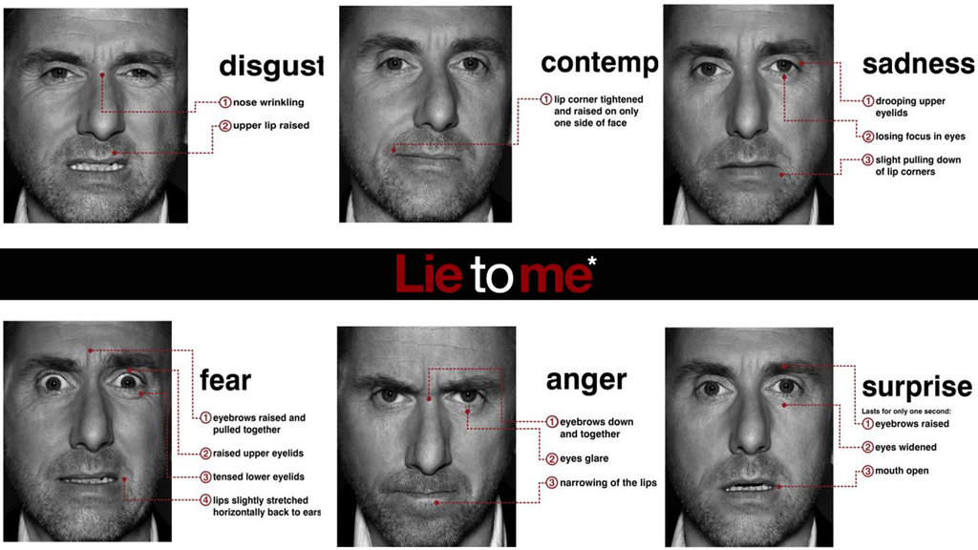By knowing how to recognize and analyze these signs it can give you an advantage in almost every situation. Besides that, it is important to realize that everyone already has an instinct to tell a person’s intention. Therefore, if you know what each body expression means, you will be able to control yourself and demonstrate only the things you want.

## **What is Body Language?**

***Facial Expressions:*** We are very drawn to looking at and observing the face to understand someone’s hidden emotions. They are an essential part of body language. Have you ever asked yourself about the possibility of a universal language? It’s already there.

***Body Proxemics:*** Proxemics is a term for how our body moves in space. We are constantly looking at how someone is moving — are they gesturing? Leaning? Moving towards or away from us? Body movements tell us a lot about preferences and nervousness. They are instrumental body language cues. We all are natural observers, that is why we’re able to evolve.

***Ornaments:*** Clothes, jewelry, sunglasses, hairstyles, these are all extensions of our body language. Not only do certain colors and styles send signals to others, but how we interact with our ornaments too. The human being is made of symbols, and most of the time we unconsciously judge a person by their clothes and accessories without even taking notice.

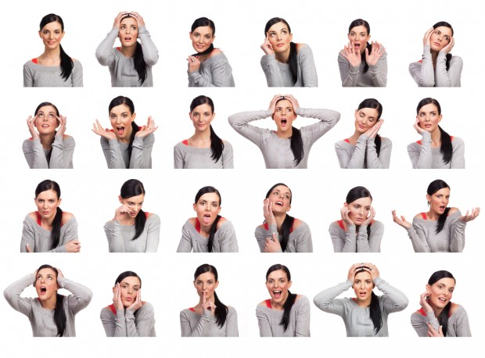

**2. How to read people’s body language**

There are actually two sides to reading body language in others.

**Decoding** is your ability to read people’s cues. It is how you interpret hidden emotions, information and personality from someone’s nonverbal language.

**Encoding** is your ability to send cues to other people. This is how you control your personal branding, what [first impression](https://www.scienceofpeople.com/2015/12/science-first-impression-tips/) you give and how you make people feel when they are with you.

**3. Man vs Female body language**

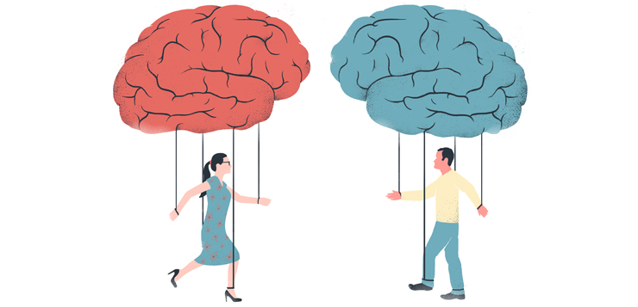

**3.1 Men and Women body language Cues**

Men use different areas of their brain to read body language and often are not as good at reading body language as women.

* Researcher Monica Moore from Webster University in St. Louis found men often miss a women’s first courtship signal. On average, women need to eye-gaze three times before a man takes notice.
* Women might be better at reading body language because [more of their brain is active](https://www.scienceofpeople.com/gender-differences/) when they evaluate other’s behavior. MRIs have revealed women have 14 to 16 active brain areas while evaluating others, whereas men only have four to six active ones.
* In another study, participants were asked to decode a silent movie. Women were able to guess what was happening 87 percent of the time, but men could guess correctly only 42 percent of the time. Interestingly, homosexual men and men in highly emotional jobs (nursing, teaching and acting) did nearly as well as women.

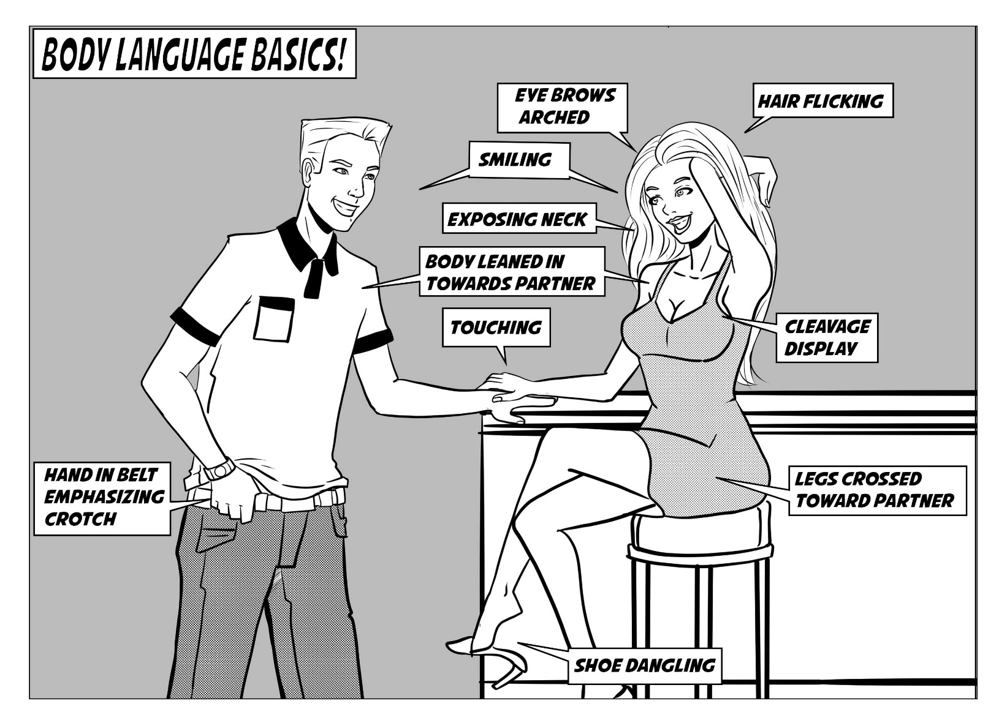

## **3.2 Men, Women and lying**

[Men and women lie for differently](https://www.scienceofpeople.com/courses/lie-detection/) motivations:

* Men lie to appear more powerful, interesting, and successful. They lie about themselves eight times more than they lie about others.
* Women lie less about themselves and more to protect others’ feelings or to make others feel better about themselves.

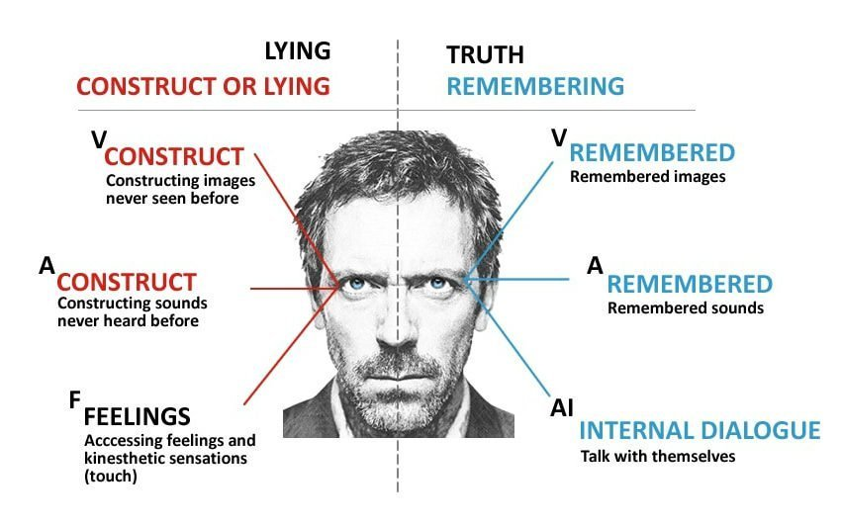

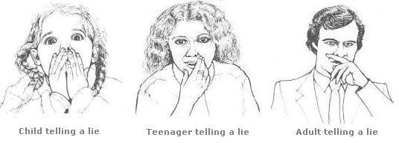

## **3.3 Men like availability over all else**

Being available is the most attractive behavior a woman has for getting a men’s interest. Studies show that men are more attracted to a woman who engages in flirtatious behavior to show she is available versus the best-looking woman in the room.

Women’s attractive behaviors for men:

* + Smiling
  + Having an expressive face
  + Minimal arm crossing
  + Keeping hands outside of pockets
  + Intimate eye gazing (from the eyes to the mouth to the body)
  + Leaning toward the other person

## **3.3.1 Male Attraction**

## Men often [point their toes](https://www.scienceofpeople.com/body-language/) toward the person they are most interested in. If they are not interested in anyone, their toes usually are pointed toward the door.

**3.4 Female Flirting Behavior**

* + Women who are trying to entice a man tend to raise their eyebrows and lower their lips because it looks similar to the face women make when they are experiencing pleasure.
  + A sideways glance over a raised shoulder highlights curves and the roundness of the female face. This signifies estrogen, exposes the vulnerability of the neck and releases pheromones. Women instinctively do this when trying to flirt.
  + A woman’s outer genitals are proportionate to her lips. This is called self-mimicry and it helps attract males. Women call attention to their lips by wearing glossy or bright-colored lipstick.
  + Women toss their hair or touch their neck when flirting because it exposes the armpit, which releases sex hormones, shows the curvature of the neck and highlights shiny healthy hair.
  + Women with large eyes, a small nose, full lips and high cheeks are seen by men as more attractive because these features usually are [correlated with high levels of estrogen](https://www.scienceofpeople.com/read-people-eyes/), which means the woman is more fertile. In men, women like legs, butt, chest and arms. The majority of women favor a man’s butt as her favorite male body part.

### 

### 

### 

### **4. Colors**

Clothing colors carry a lot of emotions: each color not only represents a mood, but also changes the mood when paired up with other colors. Hence, clothing colors are important when it comes to selecting clothes.

* **Red**: Indicates extroversion, passion, energy, and a personality type that is driven to live fully. People who like red clothes also tend to be aggressive, energetic, and quick in releasing their emotions. Red clothing colors indicate a person who is quick in judging people and expressing his opinions.
* **Orange**: Indicates sociability, a person who is well liked and makes friends easily.
* **Yellow**: Yellow clothing colors indicate a superior mind that is able to concentrate well, logical, happy, cheerful, and optimistic.
* **Green**: Indicates health, sense of balance, people who wear green are mindful about social standing reputation and financial position. They tend to live in good neighborhoods, have a lot of friends and are very social.
* **Blue**: Blue clothing colors indicate freshness, peace and loyalty, witty and sarcastic, creativity.
* **Purple**: Purple clothing colors were only used by the royalty in the past. Today, they indicate a personality type having great love for art, creativity and imagination. Such people also tend to have a deep insight. They are charming but prone to be temperamental.
* **Black**: Indicates authority, strength, power, sophistication, elegance, and authority.
* White: Indicates simplicity, precision and goodness, balance, harmony, purity, and courage.

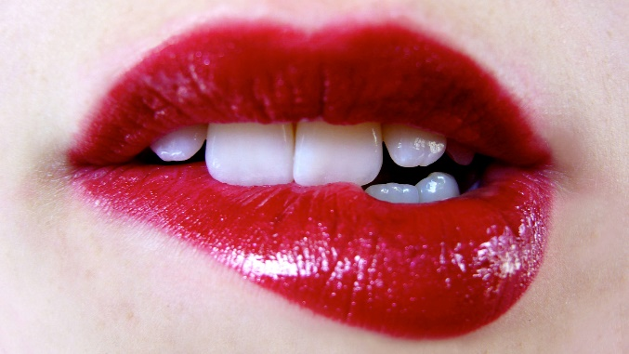**5. Body language signs of attraction backed by science**

## **5.1. The Basics of the Body Language of Attraction**

To understand modern day nonverbal signals of attraction it is helpful to look at the history of where our body language comes from. Our caveman ancestors used the same body language we use today. Here are the messages we are trying to send to potential mates with our body language, and what is seen as attractive:

* I’m open
* I’m harmless
* I’m interested
* I’m approachable
* I’m fertile

## **5.2. Step One: First Impressions**

Rutgers University anthropologist Helen Fisher says [people know within one second](https://www.scienceofpeople.com/first-impressions/) whether someone’s physically attractive or not. Here are the body language cues that people find most attractive:

* **Availability**: Both males and females find people with available body language the most attractive. Available body language is smiling, uncrossed arms, uncrossed legs and upward gazing (not looking down at shoes or phones).
* **Fertility**: From an evolutionary perspective, humans are tuned into body language cues that signal fertility and youth. Luckily, these can be emphasized with body language. [For men](https://www.scienceofpeople.com/male-body-language/), standing up straight, squaring the shoulders, planting feet slightly more than shoulder width apart and displaying hands all are signs of fertility. [For a woman](https://www.scienceofpeople.com/female-body-language/), keeping your hair down, tilting your head to expose pheromones and keeping hands and wrists visible to display the soft skin of the wrists are highly attractive for men.

## **5.2.1. Step Two: Attract Them While You Can**

Once our mind decides we like someone as a potential mate, our body automatically begins to change physically to attract the person. Our cheeks flush to make us look like we are aroused, our lips swell to look more fertile, and [even our pheromones pump](https://www.scienceofpeople.com/ever-try-smell-dating/) to attract the other person. We can do a few things to attract a mate from a body language perspective.

* **Lean In:** Leaning toward someone is a nonverbal way of telling them you are engaged. This works especially well if you are in a group of people and you are interested in one person in the group. A way to show them you are interested is by leaning toward them. This subconsciously will pull them in your direction.
* **Head Tilting:** Head tilting shows interest and engagement. If you are speaking with someone, let them know you are present and interested by tilting your head and gazing at them. Be sure not look over their head or around the room, this shows lack of interest and sensitivity.

## **5.2.2. Step Three: Find the Signs**

> Flushed and Blushed

When we are attracted to someone, blood will flow to our face, causing our cheeks to get red. This happens to mimic the orgasm effect where we get blushed. That is why women wear blush. This also happens with lips and eyes. The redder the lips and the whiter the eyes, the more fertile and attractive someone is.

> The Power of the Purse

Purse behavior is a form of nonverbal communication. It is how someone interacts with their environment based on their emotions. For example, if a woman is feeling uncomfortable or not attracted to someone, she will either clutch her bag tightly or place it in front of or covering her body. When a woman is attracted to a man, she literally and figuratively wants nothing to stand in the way between her and her man.

> Their Heart Races

Studies have found that when someone is near an attractive person their heart rate increases. Researchers tried increasing someone’s heart rate and then put him or her near a stranger. This then artificially made the person seem more attractive.

> Their Feet Like You

The feet serve as a direct reflection of a person’s attitude. The key is recognizing where a person’s feet are pointed. When the feet are pointed directly toward another person, this is a sign of attraction, or at the very least, genuine interest. If, on the other hand, the feet are pointed away, or toward the exit, that is a sign that attraction probably is not there.

## **6. Expressions**

The expression on a person's face can even help determine if we trust or believe what the individual is saying. The most trustworthy facial expression is a slight raise of the eyebrows and a slight smile. This expression conveys both friendliness and confidence.

Facial expressions are also among the most universal forms of body language. The expressions used to convey fear, anger, sadness, and happiness are similar throughout the world. Researcher Paul Ekman has found support for the universality of a variety of facial expressions tied to particular emotions including joy, anger, fear, surprise, and sadness.

Research even suggests that we make judgments about people's intelligence based upon their faces and expressions. One study found that individuals who had narrower faces and more prominent noses were more likely to be perceived as intelligent. People with smiling, joyful expression were also judged as being more intelligent than those with angry expressions.

**6.1. Eyes**

The eyes are frequently referred to as the "windows to the soul" since they are capable of revealing a great deal about what a person is feeling or thinking. As you engage in conversation with another person, taking note of eye movements is a natural and important part of the communication process. Some common things you may notice include whether people are making direct eye contact or averting their gaze, how much they are blinking, or if their pupils are dilated.

When the eyes are fully open it means the person is trying to get as much information as possible, that is why when we get surprised, afraid or we want to know more about something our eyes tend to fully open. Besides that, we can tell if someone despises you by how she is moving her eyes, rolling the eyes is one of them. Also, when we see something that we desire our pupils get dilated.

**6.2. Mouth**

Mouth expressions and movements can also be essential in reading body language. For example, chewing on the bottom lip may indicate that the individual is experiencing feelings of worry, fear, or insecurity.

Covering the mouth may be an effort to be polite if the person is yawning or coughing, but it may also be an attempt to cover up a frown of disapproval. Smiling is perhaps one of the greatest body language signals, but smiles can also be interpreted in many ways. A smile may be genuine, or it may be used to express false happiness, sarcasm, or even cynicism.

* Pursed lips: Tightening the lips might be an indicator of distaste, disapproval, or distrust.
* Lip biting: People sometimes bite their lips when they are worried, anxious, or stressed.
* Covering the mouth: When people want to hide an emotional reaction, they might cover their mouths in order to avoid displaying smiles or smirks.
* Turned up or down: Slight changes in the mouth can also be subtle indicators of what a person is feeling. When the mouth is slightly turned up, it might mean that the person is feeling happy or optimistic. On the other hand, a slightly down-turned mouth can be an indicator of sadness, disapproval, or even an outright grimace.

**6.3. Arms and legs**

Other subtle signals such as expanding the arms widely may be an attempt to seem larger or more commanding while keeping the arms close to the body may be an effort to minimize oneself or withdraw from attention.

* Crossed arms might indicate that a person feels defensive, self-protective, or closed-off.
* Standing with hands placed on the hips can be an indication that a person is ready and in control, or it can also possibly be a sign of aggressiveness.
* Clasping the hands behind the back might indicate that a person is feeling bored, anxious, or even angry.
* Rapidly tapping fingers or fidgeting can be a sign that a person is bored, impatient, or frustrated.
* Crossed legs can indicate that a person is feeling closed off or in need of privacy.



**6.4. Body**

How we hold our bodies can also serve as an important part of body language. The term posture refers to how we hold our bodies as well as the overall physical form of an individual. Posture can convey a wealth of information about how a person is feeling as well as hints about personality characteristics, such as whether a person is confident, open, or submissive.

Sitting up straight, for example, may indicate that a person is focused and paying attention to what's going on. Sitting with the body hunched forward, on the other hand, can imply that the person is bored or indifferent.

* Open posture involves keeping the trunk of the body open and exposed. This type of posture indicates friendliness, openness, and willingness.
* Closed posture involves hiding the trunk of the body often by hunching forward and keeping the arms and legs crossed. This type of posture can be an indicator of hostility, unfriendliness, and anxiety.



**CLOSING**

As we can observe, body language is the only truly universal language, because it is instinctive and natural of every human being, without the need for teaching. Moreover, the major advantage of studying about this type of communication is the simple fact that the body tends not to lie. This characteristic allows this knowledge to be used in different everyday situations with all kinds of people. So, the more you study about it, the greater your chance to recognize patterns in other people's bodies in order to deal with people in the best way possible. Consequently, increasing the success rate in your achievements.

**SOURCES:**

Content:

<https://www.mindtools.com/pages/article/Body_Language.htm>

<https://www.scienceofpeople.com/body-language/>

<https://www.verywellmind.com/understand-body-language-and-facial-expressions-4147228>

<https://www.color-meanings.com/clothing-colors-what-your-clothes-say-about-your-personality/>

<https://www.huffpost.com/entry/go-to-clothing-color_n_8286140>

Images:

<http://pedacosdafelicidade.blogspot.com/2014/09/lie-to-me.html>

<https://www.boldsky.com/relationship/love-and-romance/2012/signs-body-language-woman-flirting-110412.html>

<http://men-dating.letsbond.com/body-language-mens-flirt.html>

<https://www.everydayknow.com/female-body-language-signs-she-likes-you/>

<https://mentalizer.com/body-language-lies.html>

<https://www.learning-mind.com/eye-movements-when-lying/>

<http://www.mendaily.com/female-body-language-for-beginners-part-2/>

<https://www.icytales.com/the-difference-between-male-and-female-body-language/>

<http://www.manthesis.com/attractive-and-sexy-body-language-tips-for-men-in-dating/>